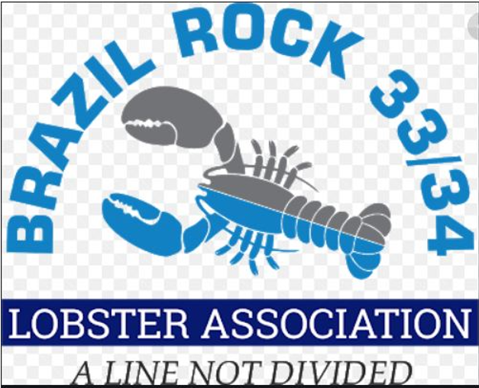

The Brazil Rock 33/34 Lobster Association is pleased to announce the student bursary program. Bursaries are available to the children and grandchildren of The Brazil Rock 33/34 Lobster Association members who are continuing their education in a field of their choice.

Ten bursaries are available for students graduating in 2023. Value: $1,000.00 each.

Bursaries are not renewable nor available for subsequent years of study.

Criteria: Applicants must be the children or grandchildren of a Brazil Rock 33/34 Lobster Association member, graduating from grade 12 and accepted into a recognized educational institution.

Applications must be submitted to the Bursary Committee by Monday, May 1st, 2023

To apply provide the following:
Proof of graduation, proof of acceptance into a recognized educational institution,
a one-page letter stating the Brazil Rock 33/34 Lobster Association member’s name,
the applicant’s name and clearly state why they are deserving of the bursary.
Submit the application via email to: brazilrock3334@gmail.com

The successful candidates will be selected by the Brazil Rock 3334 Lobster Association’s Bursary Committee and notified by phone.

For additional information on The Brazil Rock 33/34 Lobster Association Bursary program, please contact the office at (902) 749-6233 or email at brazilrock3334@gmail.com

